# CDBM 190 Introduction to Database Management

## Assignment 2: Create Reports

Given: March 24, 2022

Due: April 8, 2022 at 11:59pm

Make sure to download the Oakmont database file and use that for this assignment. Submit the finished database to the CDBM190 Brightspace Dropbox. Perform a compact and repair before submitting the file.

### General guidelines

All reports will be evaluated with respect to the following criteria:

1. All data in each field is visible.
2. Text and numbers are appropriately aligned.
3. Pages and sections are sized to minimize wasted space.
4. Use of appropriate shading and colours.
5. Use of appropriate fonts.

### Reports to create (marks indicated for each question)

1. **Student Enrollment and Grades**

Create the report **rptStudentsEnrollGrades**, with subreports **subRptStudentsEnroll** and **subRptStudentsGrades**, as per the following specifications.

* 1. Description of Layout:

See Figure 1 on page 4.

* 1. Data source:
     1. The main report should only use the Students table. Ensure the student name is formatted as “LASTNAME, FirstName”.
     2. When the report is run, the user should be prompted to enter a StudentID pattern to match.
     3. The enrollment subreport draws its information from the Enrollments, Sections, and Courses tables.
     4. The grades subreport draws its information from the Grades and Courses tables.
  2. Report details:
     1. The report title "Student Enrollment and Grades" should appear at the top of the first page only.
     2. The page numbers should appear at the bottom of every page.
     3. A double line should precede each student.
     4. Show all fields related to the student record. The student's state or province should show the full name of the state or province instead of the abbreviated code (e.g. show "Saskatchewan" instead of "SK"). The full name is stored in the StatesProvinces table.
     5. The enrollment subreport should show all enrollment records associated with the current student. Include the course id, the course name, the section number, and the full name of the section's professor in the format “LASTNAME, F.”, where “F” is the first initial of their FirstName
     6. The grades subreport should include all grade records associated with the current student. Include the course id, the course name, the credit units, the year, the semester, the grade, and the quality points (the Grade multiplied by credit Units). At the bottom of the subreport, include a calculation of the weighted GPA (Divide total quality points by total units).

[25 marks]

1. **Enrollment by department report**

Create the report **rptDeptCourseSectStu** as per the following specifications.

* 1. Description of Layout:

See Figure 2 on page 5.

* 1. Data source:
     1. Review the layout as described in point (2)(a) above and the details in point (2)(c) below to determine the appropriate tables/queries required.
     2. To make the number of rows more manageable, restrict the departments to Anthropology, Biology, and Computer Science.
  2. Report details:
     1. The report title "Course Enrollment by Department" should appear at the top of the first page only. In an 18pt bold italic font. The date the report was created should appear on the right edge in an 8pt font in the form "March 23, 2022".
     2. The top of every page (after the title on the first page) should display the department information in the form of "Department: DepartmentDescription (DepartmentID)", for example "Department: Anthropology (ANTHRO)". The department information should use a 14pt bold font. This information should be displayed on a darkened background.
     3. The bottom of every page should show the page numbering.
     4. Each department should start on a new page.
     5. Each course should start on a new page
     6. For each department, list the courses offered by that department. The course information should include the course id, the course name, the credit units, and the capacity. Bold the course name.
     7. For each course, list the sections offered. Include the section number, days (see below), start time, length, and professor's name.
        1. If days value is "MWF", display "Monday, Wednesday, Friday"; if the days value is "TTh", display "Tuesday, Thursday", and if it is neither, display the value for days.
        2. The professor's name should be displayed as "LASTNAME, FirstName".
        3. Have this information stand out via a Rectangle control and pick a soft colour.
     8. For each section, list the students enrolled in that section. Display the student id, the student's name (in the form "LASTNAME, FirstName"), and the student's email. The records should be sorted by the student's last name and then first name.
     9. After showing each section's enrolled students, show a count of the number of students in that section. Also include summaries (with appropriately shaded backgrounds) for each course, department, and for the report as a whole. After each course summary, have a horizontal line display.

[25 marks]

### Layout sketches

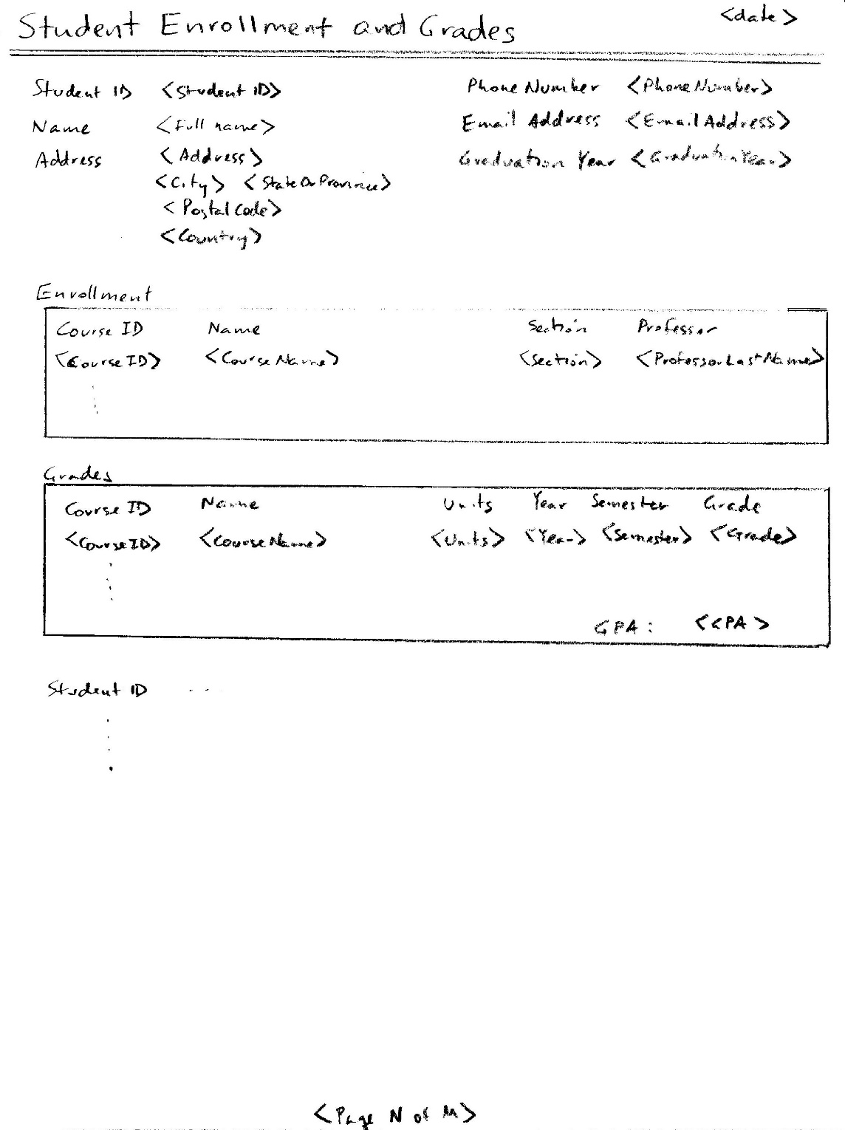

Figure 1 – Student Enrollment and Grades Report

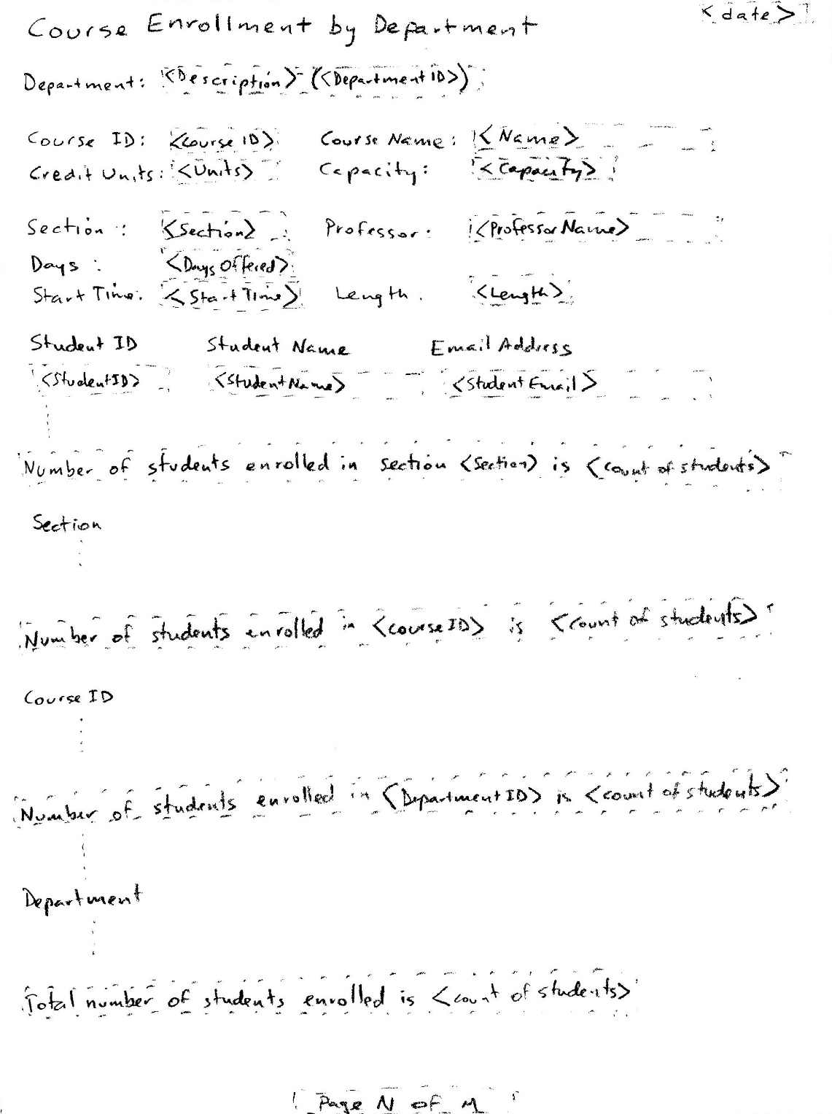

Figure 2 – Course Enrollment by Department Report